ADRIAN TURION |  | Avenue de Sainte-Clotilde 9  1205 Geneva, Switzerland | 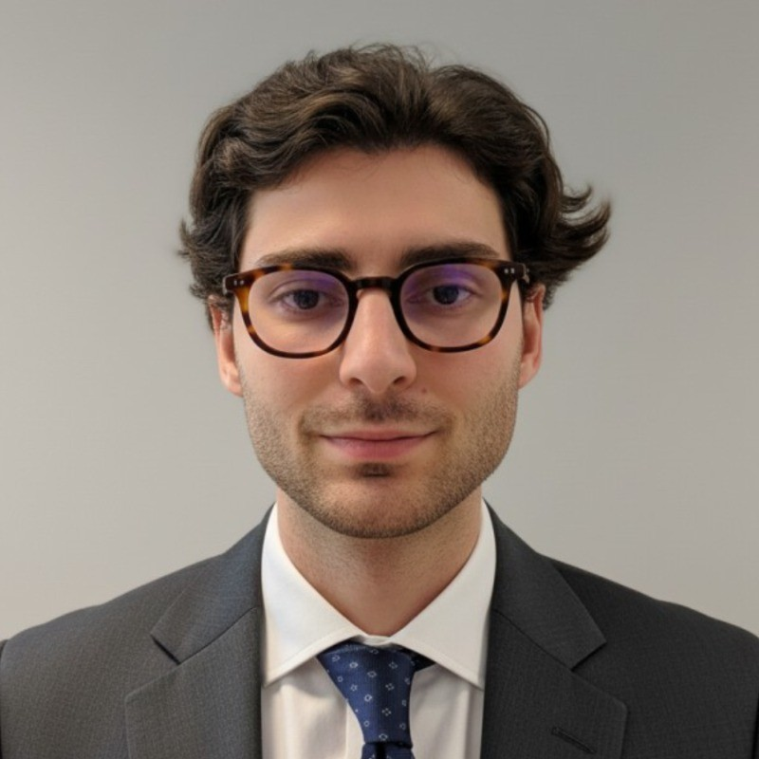
turionadrian@gmail.com | Swiss | 10.11.2000 |  | +41 77 262 37 96
INTRODUCTION
Finance professional with M&A and derivatives experience, seeking to leverage analytical skills and client-facing expertise at FIS Geneva. Demonstrated track record in relationship building and financial analysis across cross-border transactions. Strong understanding of risk management and market intelligence from managing personal derivatives portfolio and executing multi-sector M&A mandates.
WORK EXPERIENCE
Auraïa Capital Advisory – Small & Mid Cap Cross-border M&A Boutique  Mergers & Acquisitions Analyst (Converted internship into full-time position) |  | Geneva, Switzerland  Aug 2024 – Current
- Managed relationships with clients, advisors, and counterparties throughout transaction lifecycle across 7 live mandates in healthcare, tech, and life sciences sectors with deal values ranging from EUR 5M to EUR 50M
- Built detailed financial models including LBO, DCF, trading comps, and precedent transactions while performing quality of earnings analysis to identify key value drivers and support client presentations for Board meetings
- Conducted comprehensive industry research and identified strategic buyers for cross-border deals spanning Europe, US, and Asia, coordinating with legal, tax, and accounting advisors to structure transactions

RC Group – Currently under LBO with Crédit Mutuel Equity  Mergers & Acquisitions Intern |  | Paris, France  Feb 2024 – Aug 2024
- Worked directly with the CEO of Healthcare and Retail divisions on evaluating multiple acquisition targets in France and Belgium, preparing investment memos including market analysis, competitive positioning, and financial projections for 3 potential acquisitions with revenues of EUR 10M-30M

Europ Assistance – Subsidiary of Generali Insurance  Financial Analyst Intern |  | Geneva, Switzerland  Apr 2023 – Aug 2023
- Built automated financial dashboards in Excel and PowerBI to track KPIs and performed variance analysis on monthly P&L results, supporting the CFO on FP&A and strategic projects for Swiss subsidiary with CHF 50M+ revenues while assisting in annual budget planning and quarterly forecasting

LEADERSHIP
- Led post-COVID financial recovery at AIESEC by sourcing corporate leads and negotiating partnerships, closing 3 key deals generating CHF 60K annual revenue and increasing volunteer placements by 40%
- Presented strategic project as finalist in 2024 McKinsey-sponsored business case, developing data-driven model to forecast black swan events with potential CHF 200K annual revenue gain
- Manages diversified investment portfolio using options strategies with 45-day expiries, generating consistent income through theta decay while managing risk with ETFs
EDUCATION
HEC Lausanne  Master of Science in Finance |  | Lausanne, Switzerland  2021 – 2024
- Cumulative GPA: 5.2/6.0 (Top 15% of the class cohort)
- Exchange programs at Waseda University (Tokyo, Japan) and Maastricht University (Maastricht, Netherlands)
- Relevant Coursework: Derivatives, Fixed Income and Credit Risk, Investment and Portfolio Management, Risk Management
- Thesis Topic: Synergies Analysis of the Merger between American Airlines & US Airways

Bachelor of Science in Management |  | 2018 – 2021
- Cumulative GPA: 4.7/6.0

Scientific Baccalaureate with Highest Honors (16.6/20) |  | Aix-en-Provence, France
ADDITIONAL INFORMATION
Languages:  Computer:  Interests:  References: | French (Native, C2), Spanish (Native, C2), English (Fluent, C1), German (Business proficient, B2-C1)  Financial Modeling | Derivatives | Risk Management | Market Analysis | Excel  Geopolitics, Badminton (Provence regional finalist), Gym, Real use cases of Artificial Intelligence  Guillaume Arnaldez – Ex-Director at Auraïa Capital Advisory, guillaume.arnaldez@auraia.ch  Sacha Caravatti – CFO at Europ Assistance Switzerland, scaravatti@europ-assistance.ch

